**AIM:**

Write a C program to find Factorial of a given number using Recursion

**ALGORITHM**

• **Start**

• Read the number n.

• If n < 0, print *“Factorial not possible”* and **Stop**.

• Define a recursive function factorial(n) as:

* If n == 0 or n == 1, return 1.
* Else return n * factorial(n - 1).

• Call factorial(n) from the main program.

• Print the result.

• **Stop**

**CODE**

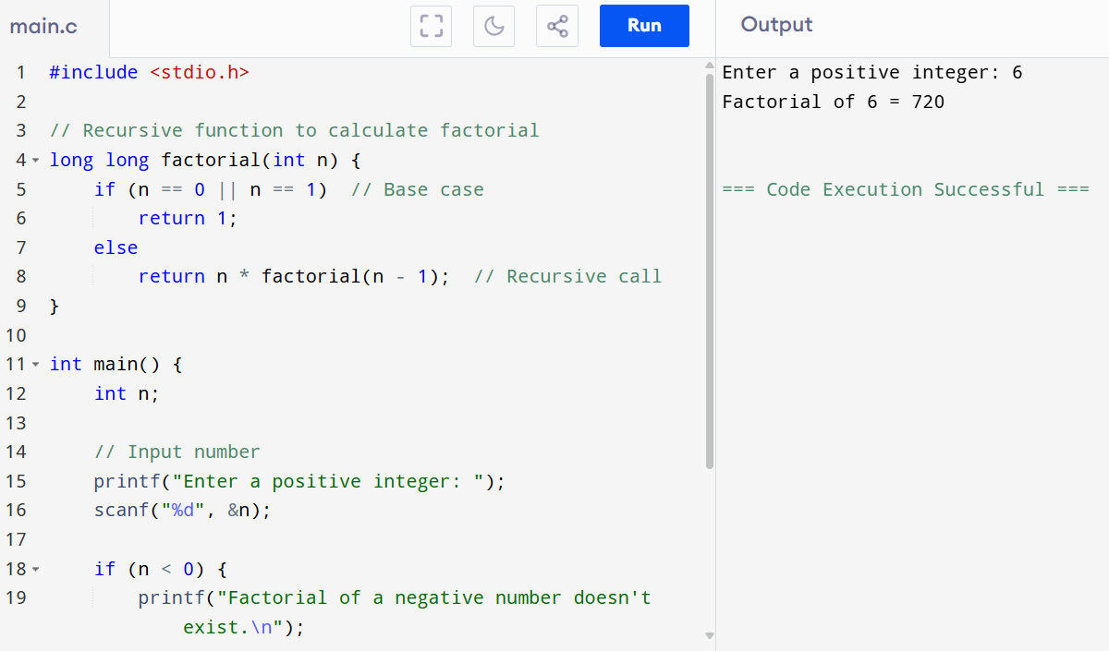

**OUTPUT**

Enter a positive integer: 6

Factorial of 6 = 720